Yiannis Constantinides
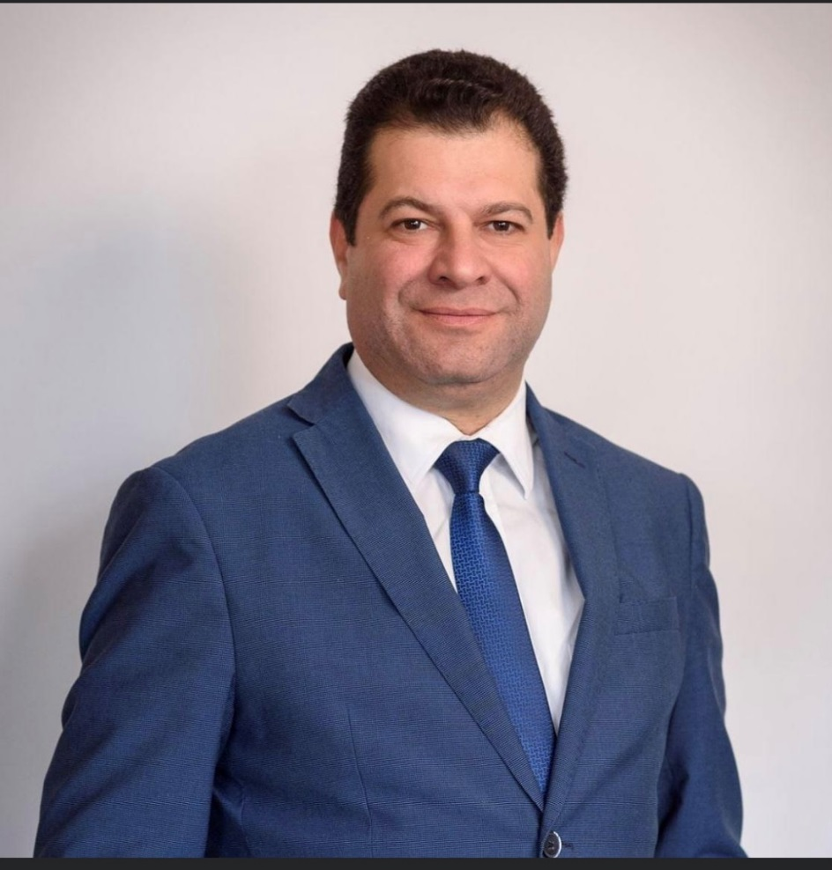
Yiannis Constantinides was born in Johannesburg (S.Africa) in 1973.He graduated with honors from the Kykkos Lyceum in Paphos in 1991 and then completed his military service in 1993.Between 1993 and 1996 he studied Accounting and Finance at the University of Manchester and then qualified as a Chartered Certified Accountant and is a member of the Association of Chartered Certified Accountants (ACCA) since 1999. He is also an active member of the Institute of Certified Public Accountants of Cyprus (ICPAC) since 2000.
In 2007 he founded the audit firm Yiannis Constantinides Ltd, Chartered Certified Accountants and he is the Managing Director. The company provides a wide range of services such as accounting, audit, tax and advisory. Previously he worked as a manager at PWC and KPMG in Cyprus. He also worked as trainee accountant at Βennett Verby & Co και Clement Keys & Co in the United Kingdom.
He is the Chairman of the Audit Committee of the Cultural Association Evagoras Pallikarides. He was a Member of the Committee of Co-Operative Credit Society Pegeias Ltd and Member of the Committee of the Paphos Co-Operative Savings Society Ltd. In July 2016 he was appointed as Member of the Board of Directors of Electricity Authority of Cyprus (ΕAC) where he also served as Chairman of its Audit Committee until the end of his term in January 2019. He was Member of the Board of Directors of the Cyprus Telecommunications Authority (CYTA), since 31 January 2019 and in December 2020 was appointed as Vice Chairman of CYTA until the end of his term in July 2021. In November 2022 he was appointed as Member of the Board of Directors of Cyprus Health Insurance Organization (HIO).

